

MANUAL

Basic functions

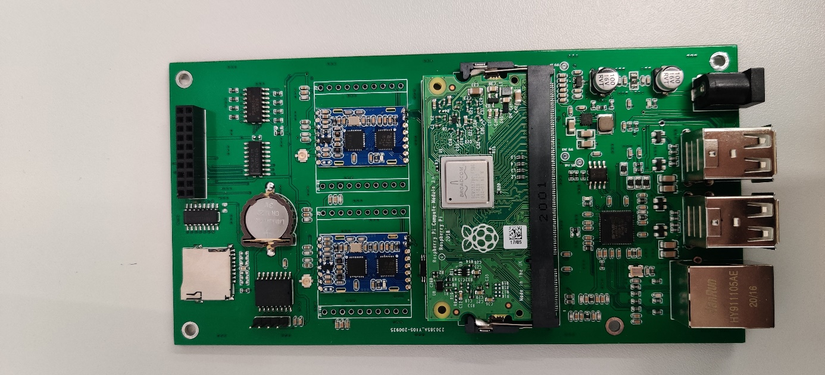
ID Control 500

Version: v1.0
Date: 19.02.2021

CONTENT
CONTENT 2
1 Login 3
2 Communication to RFID Module M900-DES 3
2.1 Display output (only ascii): 3
2.2 Activate Tag Piccactivate (50 00 02 22 10 52 32): 3
3 Serial interface 4
4 Control GPIO 5

Login

User :PI
PW : raspberry
User : root
PW:panettone

Communication to RFID Module M900-DES

-the module are connected to /dev/ttyS0 and /dev/ttyAMA0 with these values :
Baudrate :115200
DataBits: 8
Parity:NONE
StopBits: 1
FlowControl: NONE

Display output (only ascii):
tio /dev/ttyS0
tio /dev/ttyAMA0

To communicate with the desfire m900 module , you need a terminal which can display hex output.

read FW Version :

echo -e "\x50\x00\x00\x04\x54" > /dev/ttyS0

echo -e "\x50\x00\x00\x04\x54" > /dev/ttyAMA0

Activate Tag Piccactivate (50 00 02 22 10 52 32):

You need the correct access rights to communicate with this interface :
sudo chmod -v a+rwx /dev/ttyAMA0
sudo chmod -v a+rwx /dev/ttyS0

echo -e "\x50\x00\x02\x22\x10\x52\x32" > /dev/ttyS0
echo -e "\x50\x00\x02\x22\x10\x52\x32" > /dev/ttyAMA0

Serial interface

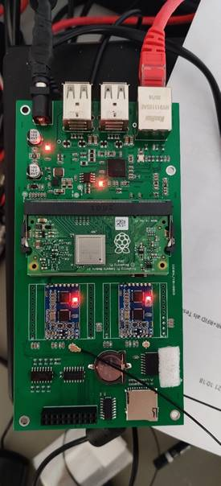
ttyS0
ttyAMA0

Control GPIO

First GPIO should be exportet :
root@raspberrypi:/home/pi# echo "40" > /sys/class/gpio/export
root@raspberrypi:/home/pi# echo "out" > /sys/class/gpio/gpio40/direction
Now you can control the GPIO :
Example :
Turn GPIO on
root@raspberrypi:/home/pi# echo "1" > /sys/class/gpio/gpio40/value
Turn GPIO off :
root@raspberrypi:/home/pi# echo "0" > /sys/class/gpio/gpio40/value

